VILLAGE HALL HIRE AGREEMENT

This Hire Agreement is between Hughenden Valley Village Hall Management Committee (HVVHMC) and the Hirer.

The Village Hall Management Committee shall mean:

Name | The HVVHMC
Address | Hughenden Valley Village Hall  Coombe Lane  Hughenden Valley  High Wycombe  HP14 4NX
Contact telephone number | 07815 163269
E-mail address | bookings@hughendenvillagehall.co.uk
Registered Charity number | 300282

Standard and Other Conditions

THE HIRER’s attention is drawn to the Standard Terms and Conditions that are included and form part of this Agreement an understanding of which the Hirer acknowledges.

THE HIRER must be over 21 years old.

The HVVHMC agrees to permit the Hirer, for the Hire Fee, to use the Identified Premises, for the Hire Period and on the terms and conditions as follows:

THE HIRER agrees to be present during the Hire Period; if he/she cannot be present, then they must ensure a responsible person is. In the event the Hall is left unoccupied at any time the Hirer must advise the Bookings Secretary.

Times include preparation and clearing up as the Identified Premises are only available for the times stated.

The Premises shall not be used for licensable activities except between the hours set out in the Hire Agreement unless special permission has been issued by Buckinghamshire Council and by the Hughenden Valley Village Hall Management Committee.

If alcohol is for resale the hirer is required to seek a Temporary Event Notice from Bucks CC. This needs to be obtained at least ten days in advance and a copy must be provided to booking secretary no less than one week prior to the event.

Subject to availability and with the approval of the HVVHMC, the hirer may use the village halls tables, chairs, glasses, crockery, cooking utensils, cleaning materials and equipment. These items must be returned to their allocated storage location in a clean condition.

The hirer’s attention is drawn to the end of function close down instructions that are included at the end of this agreement.

The Hirer agrees to cease all music and to vacate the Identified Premises by 12 midnight unless otherwise agreed with the Bookings Secretary.

Contact Details

Bookings Secretary: 07815 163 269 bookings@hughendenvillagehall.co.uk

Schedule of Standard Conditions

The terms The Hughenden Valley Village Hall Management Committee (also referred to herein as HVVHMC), Hirer, Identified Premises, Hire Period and Purpose have the meanings attached to them in the associated Hire Agreement.

HVVH means Hughenden Valley Village Hall

The Hall includes the large Hall, the Small Hall, the Committee Room and/or any facility available for Hire within the facilities and curtilage of HVVH
If the Hirer is in any doubt as to the meaning of any of the following they should contact the HVVH Bookings Secretary.

1. Supervision
THE HIRER will, during the Hire Period, be responsible for supervision of the Identified Premises, the fabric and the contents; their care, avoidance from damage however slight; or change of any sort and the behaviour of all persons using the Identified Premises whatever their capacity. If for any reason the emergency services are required THE HIRER is responsible for their call out via a mobile phone. A plan of the halls showing the emergency exits and emergency equipment available is shown at the end of this document.
THE HIRER shall ensure they are aware of the fire exits and the location of the fire assembly point and take responsibility for managing evacuation of all attendees if necessary. (These details are found in the entrance to the Large Hall and on the notice board in the Small Hall). The Hirer shall ensure that fire exits and fire-fighting equipment are kept accessible. Regular hirers have to undertake a fire drill every six months.
Supervision shall extend to include car parking arrangements so as to avoid obstruction of the Highway and access to the Village Shop.

2. Use of Identified Premises
THE HIRER shall not use the Identified Premises for any purpose other than that described in the hiring agreement and shall not sub-hire or use them, or allow them to be used, for any unlawful purpose or in any unlawful way, nor do anything to bring anything onto them which may endanger them, or render invalid any insurance policies in respect of them.
THE HIRER shall ensure that no equipment is used or activity takes place which could result in the setting off of smoke/heat alarms or emergency services being required.
No smoking, naked flames or candles are permitted inside the Identified Premises.
No BBQs or hog-roasting equipment are allowed without specific prior agreement of The Management Committee and within prescribed areas of the facility. Such equipment shall be attended to by a responsible adult at all times.
THE HIRER shall ensure that:
No highly flammable substances are bought into or used in any part of the premises
No supplementary heating devices are to be brought into or used in any part of the premises
No Halogen lights are to be used within the premises, only LED and low heat output lighting systems are allowed
No flammable decorations (e.g. polystyrene, cotton wool, paper) are to be erected without the prior consent of the Management Committee. No decorations are to be erected near to light fittings or heaters
No decorations, pictures, notices etc. are to be affixed to walls without prior approval of the management Committee and under no circumstances is anything to be fixed/glued/taped to the Acoustic Wall-Panels.
No damage is caused to the wood flooring e.g. scratches, adhesive tape marks etc
No Fireworks are brought into or ignited within the Halls, car park or playing fields
All kitchen equipment is used in accordance with the displayed operating instructions.

3. Licences
THE HIRER shall be responsible for obtaining such licences as may be needed, whether for the sale or supply of alcohol or otherwise, and for the observance of the licences. The Hirer hereby indemnifies the Village Hall Management Committee against any infringement of such licences or breaches of copyright or Intellectual Property.
(See also condition 16 Noise).

4. Gaming, Betting and Lotteries
THE HIRER shall ensure that nothing is done on, or in relation, to the Identified Premises in contravention of the law relating to gaming, betting and lotteries.

5. Public Safety Compliance
HUGHENDEN VALLEY VILLAGE HALL MANAGEMENT COMMITTEE shall comply with all conditions and regulations made in respect of the identified Premises by the Fire Authority, Local Authority, local Magistrates’ Court or otherwise, particularly in connection with any event which includes public dancing or music or other similar public entertainment or stage plays.
HUGHENDEN VALLEY VILLAGE HALL MANAGEMENT COMMITTEE has an obligation to comply with its Premises Licence. The Hirer is required to make themselves aware of and comply with the contents of that Premises Licence and, in signing a Hire Agreement, confirm that they have done so. The Premises Licence can be viewed on the Hall’s website or a hard copy is available for inspection at the Hall.

6. Health, Safety and Hygiene
HUGHENDEN VALLEY VILLAGE HALL MANAGEMENT COMMITTEE has instigated a ‘Risk Assessment’ and ‘Fire Risk Assessment’ for the Village Hall. The Hirer is required to make themselves aware of and comply with the contents of those Risk Assessments and, in acknowledging this agreement, confirm that they have done so. The Risk Assessments can be viewed on the Hall’s website. The Hirer may need to supplement the Hall’s Risk Assessments with their own depending on the activity being undertaken. It is the Hirers responsibility to assess that need and HVVHMC accepts no responsibility for any deficiency in this respect.
THE HIRER shall, if preparing, serving or selling food, observe all relevant food health and hygiene legislation and regulations. No food to be left on Identified Premises without prior permission.

7. Electrical Appliance Safety
THE HIRER shall be responsible for the safe use of any electrical appliances. Ensuring that PAT testing certificates alongside Liability insurance certificates have been sourced from any suppliers the Hirer is using i.e. DJ’s, entertainers etc.
THE HIRER shall ensure that any electrical appliances brought by them to the Identified Premises and used there, shall be safe and in good working order and used in a safe manner. Where a residual circuit breaker is provided, the Hirer must make use of it in the interests of public safety. Work, modifications or changes to the fixed electrical installations is not allowed. Any specific requirements must be addressed to the Bookings Secretary.

8. Indemnity and Insurance
THE HIRER shall indemnify HVVHMC for the cost of repair of any damage done to any part of the property within the curtilage thereof or the contents of the buildings which may occur during the period of the hiring as a result of the hiring.
THE HIRER shall indemnify HVVHMC against any third party claims which may lie against him or her (or the organisation if acting as a representative) whilst using the Identified Premises which may arise as a result of the hiring.
THE HIRER shall be responsible for, and indemnifies HVVHMC against all liability for personal injury, except insofar as the same may be caused by the negligence or breach of strict statutory liability of the Village Hall Management Committee.
If THE HIRER is a commercial association or a profit making organisation they agree to obtain third party public liability insurance for their event for a minimum amount of £5,000,000 for any one occurrence or series of occurrences arising out of one event. HVVHMC accepts no liability for any claims arising thereof. Evidence that The Hirer has the necessary insurance in place will be required.
HUGHENDEN VALLEY VILLAGE HALL MANAGEMENT COMMITTEE will not be held responsible for any loss or damage to Hirers’ or Third Parties’ property during the time of hiring and the Hirer confirms that they or the relevant owners will retain all risk in and will adequately insure all such property.
9. Accidents and Dangerous Occurrences
THE HIRER must record all accidents involving injury to the public in the accident book located in the kitchen and report to the Bookings Secretary by the end of the event (in accordance with contact details given in the Hire Agreement). Certain types of accident or injury must be reported under the Reporting of Injuries, Diseases and Dangerous Occurrences Regulation 2013 (RIDDOR). This will be undertaken by the HVVHMC after being advised of the occurrence. Any failure of equipment, either that belonging to HVVHMC or to the Hirer must also be reported as soon as possible.

10. Animals
THE HIRER shall ensure that no animals (including birds) except assistance dogs are brought into the Identified Premises, other than for a special event agreed by HVVHMC (prior agreement in writing must be given). No animals whatsoever are allowed in the kitchen at any time.

11. Activities for Children
THE HIRER shall ensure that any activities for children comply with the provisions of appropriate legislation and regulations and that only fit and proper persons have access to the children.

12. Sale of Goods
THE HIRER shall, if selling goods on the Identified Premises, comply with the provisions of appropriate legislation and regulations for the supply and selling of such goods.

13. Cancellation
Cancellation of a booking by a Hirer must be made to the Committee’s Bookings Secretary and will only be effective once confirmed by them in writing. The cancellation will be effective from the day of receipt of such notice. If the Hirer needs to cancel a booking, for whatever reason, they will then become liable to pay the Committee a cancellation fee as follows:
- 8 weeks prior to event - Full refund
- 4 weeks prior to event - 50% refund
- 2 weeks prior to event - 25% refund
- Less than 2 weeks - no refund

The Committee reserves the right to cancel this hiring by written notice to the Hirer in the event of:
- The premises being required for use as a Polling Station for a Parliamentary or Local Government election or by-election.
- The Committee reasonably considers that a breach of licensing conditions, legal or statutory requirements or unlawful or unsuitable activities will take place at the premises as a result of this hiring.
- The premises becoming unfit for the use intended by the Hirer.
- An emergency requiring use of the premises as a shelter for the victims of flooding, snowstorm, fire, explosion or those at risk of these or similar disasters.
In any such case the Hirer shall be entitled to a refund of any deposit already paid, but the Village Hall shall not be liable to the Hirer for any resulting direct or indirect loss or damages whatsoever.
14. Noise
THE HIRER shall, in consideration of neighbours and all local residents, and as required by granted licences, keep volume of noise and music down to a reasonable level, and ensure that noise generally is kept to a minimum on arrival, during the event and on departure from the Identified Premises.

THE HIRER must ensure that all windows and doors are closed and, in hours of darkness, curtains drawn closed whilst music is playing.
If one has been prepared, THE HIRER must comply with the noise plan.
15. End of Hire
THE HIRER shall ensure that, for an evening booking, all music will cease and the Identified Premises are vacated by no later than midnight or such later time if an extension has been agreed or such other times appropriate to any licence extension.
THE HIRER shall be responsible for leaving the Identified Premises and surrounding area including the car park in a clean and tidy condition, properly locked and secured unless directed otherwise, and any contents temporarily removed from their usual positions properly replaced, otherwise HVVHMC shall be at liberty to make an additional charge/deduction from the deposit paid.
Keys must be returned to the Bookings Secretary immediately after the Hire period ends, or at such time as may have been previously agreed with the Booking Secretary. A charge of £65.00 will be made for lost keys.
16. Data Protection
In order of compliance with GDPR General Data Protection Regulation (GDPR) -
Hughenden Valley Village Hall uses personal data for the purposes of managing the hall, its bookings and finances, running and marketing events at the hall, staff employment and its fundraising activities.
Personal data will only consist of name, address, telephone number and email address.
Data may be retained for up to 7 years for accounts purposes and for longer where required by the hall’s insurers.
Your data will not be shared to other business or sponsors.
If you would like to find out more about how we use your personal data or want to see a copy of information about you that we hold, please contact the hall secretary.
17. Capacity and Supervision
- The number of people on the premises shall not exceed 200 standing or 110 seated for the Large Hall and 60 standing and 40 seated for the Small Hall For alternative hall layouts please consult with the booking secretary.
- There shall be, in addition to the HIRER, a minimum of:
2 x competent attendants for up to 100 persons
an additional competent attendant for each additional 50 or part thereof.
on duty on the premises to assist people entering and leaving, none of whom shall be less than 18 years of age.
If the majority of the audience is under 15 years of age and/or there are many disabled people then the number of attendants shall be not less than:
3 x competent attendants for up to 100 persons
3 x additional competent attendants for each additional 50
All persons on duty shall have been instructed as to their essential responsibilities in the event of fire or other emergencies including attention to disabled persons, the location and use of fire-fighting equipment available, how to call the fire brigade and evacuation procedures.
18. Age
The HIRER, not being a person under 21 years of age, hereby accepts responsibility for being in charge of and on the premises at all times when the public is present and for ensuring that all conditions of the Premises Licence and/or the Operating Schedule relating to management and supervision of the premises are met.
19. Dangerous and Unsuitable Performances
Performances involving danger to the public, or of a sexually explicit nature, shall not be given.
20. Film Shows
Children shall be restricted from viewing age-restricted films classified according to the recommendations of the British Board of Film Classification.

The Hirer
I/WE THE HIRER AGREE TO COMPLY WITH THE ABOVE SCHEDULE OF STANDARD CONDITIONS AND ACCEPT THEM TO BE PART OF THE HIRE AGREEMENT BY COMPLETING THE BOOKING APPLICATION.

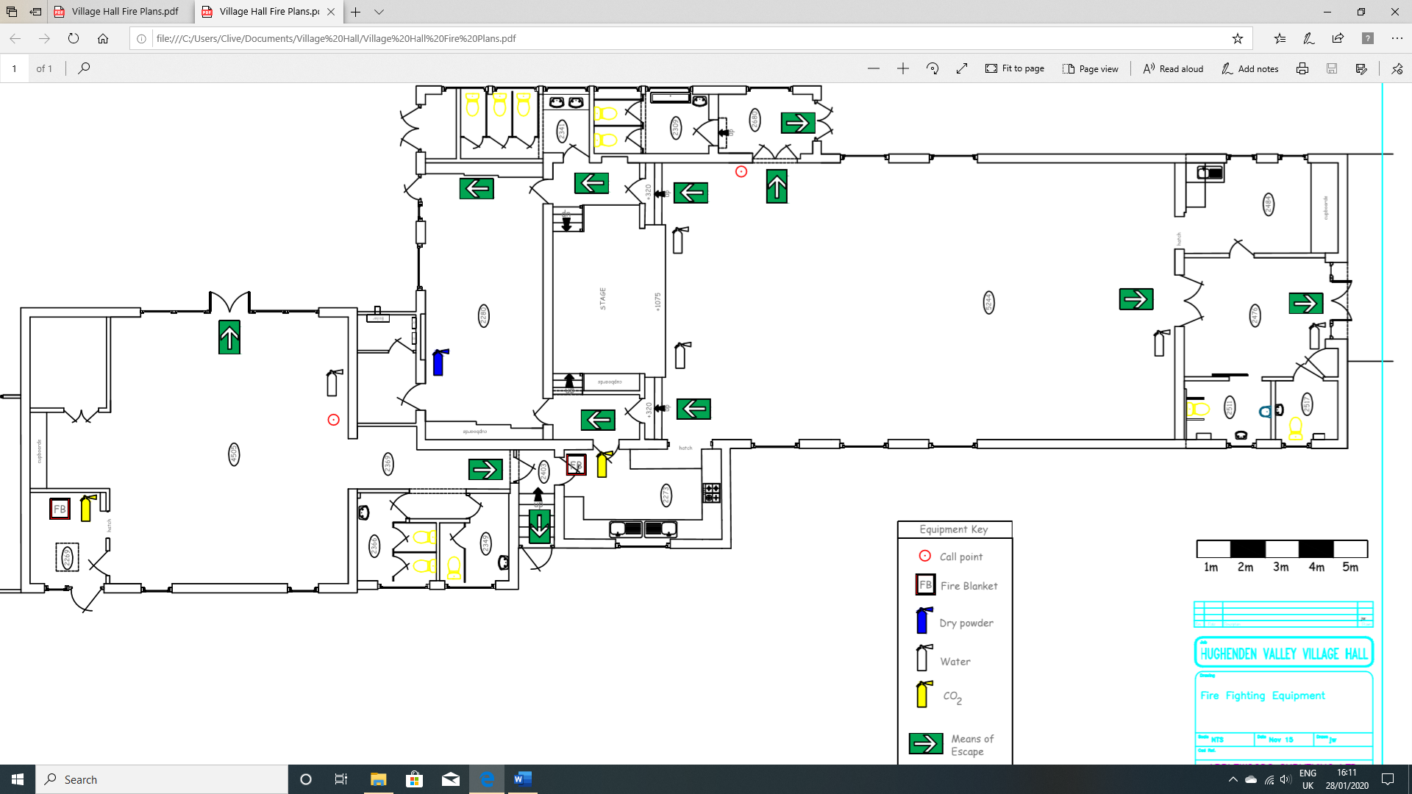

HALL CLOSE DOWN INSTRUCTIONS

If arrangements have been made for the Hirer to close down the Hall at the end of their event, the following task, as relevant, should be addressed.

Generally
- Please leave the Hall as you found it, hopefully in a clean and tidy state. Please sweep or dry mop the floor(s); if necessary, wet mop any spillages, etc.
- Return all equipment, tables, chairs, utensils, glasses, crockery, etc in their correct storage space in a clean condition.
- All lights to be turned off.
- Please check that all external doors and windows are securely locked.
- Curtains must be drawn open.
- Ensure all internal doors are closed; they should not be wedged open – some are fire doors.
- Cleaning utensils and materials can be found in the Cleaners’ Cupboard.
- Empty ALL bins into the outside refuse bins
- Ensure the car park is left in an orderly state

Specifically; Kitchen
- Remove any of your contents from the fridge/freezers.
- Check dishwasher is at the “Off” position, drained and clean as per the instructions on the door. Do not turn off at the mains switch
- Empty kitchen bin into the outside refuse bin.

Security
- Ensure that all exit doors are secure on leaving the premises.

