

Annual General Meeting
  - 5 January 2026
  - Meeting Minutes

Attendees
Name | Role | Name | Role
Andrew Flint | HAGA | Maureen Haskell | HAG
Angus Idle | HVRA | Natalie Wilson-Jones | Booking Secretary
Bob Cook | Grounds & Maintenance | Paul Cooper | Art Group
Bob Hawkins | Resident | Paul Woodford | Resident
Diana Gibbons | Trustee / Valley Players | Peter Cannon | Resident
Geoff Wickett | Resident | Peter Gieler | Committee Chair
Graeme Card | Trustee | Roland Wales | Committee Treasurer
Graham Hall | Football Club Chair | Rosemary Hewitt | Resident
Jasper McGuire | Committee Secretary | Richard Adams | Resident
Joe Cook | Resident | Sam Morrison | Trustee
John Pateman | Resident | Simon Keary | HPC
John Moorby | Conservation Group | Stefan Gieler | Resident
Mary Hilder | Resident | Stuart Gibbons | Resident

Opening/Welcome
The meeting was opened at 19:30 by Committee Chairman, Peter Gieler.

Apologies
Louise Jones

Approval of last year’s AGM minutes
Proposed: Richard Adams
Seconded: Simon Keary

Chairman’s Report
2025 has been a far more rewarding year for the Management Committee. We now have a Treasurer and Secretary firmly established and extremely efficient in their posts. I, as Chairman, feel that we are on far firmer ground and instead of struggling to keep our heads above water and on a far more positive course.
My especial thanks go to Bob, Natalie and Jenny for their wonderful efforts regarding management, maintenance and bookings of the hall. We would be totally lost without them.
All members of both the management Committee and Trustees have again been enthusiastic and devote as much time and effort as their personal circumstances allow. Bob, Natalie and Jenny attend the monthly meetings to update the committee first hand and enable us to resolve any difficulties or problems. We have achieved a great deal.
Our maintenance of the building has been professionally and superbly led by Bob Cook who has dealt with several projects during the year both minor and major, under the guise of our major Health and Safety Review we have introduced new procedures and reviewed all our facilities.
There are now monthly review meetings by the Chairman with Bob and with Jenny, our Health and Safety Representative. A thorough checklist is strictly adhered to and acted upon. All electric points have been professionally checked and passed; all plumbing conforms to current Legionella requirements and all fire procedures and warnings updated. We are very grateful to Hughenden Parish Council for providing a generous grant to help finance the plumbing project.
We have also had a security problem during the summer and without an accountable checklist of key and fob folders it was unanimously decided to update the security of the building introducing up-to-date technology and reduce the number of keys. Simultaneously, we have improved our CCTV coverage of the site.
We have also reviewed and streamlined our management and accountability systems and procedures which will help the management committee in the future.
Our Playground continues to thrive, and we are looking to improve our facilities during the next year. We have installed a permanent gazebo for use by the preschool as well as hirers. This will provide shade during hot summer days.
We had a very successful Christmas Fair mainly thanks to the organisational skills of Kerry Franklin, who was assisted hugely by Natalie, Jenny and Diana. Thank you so much.
We have unfortunately to report that we have found difficulties in recruiting new volunteers and this has meant severe curtailment of our programme of events. The lack of volunteers is a nationwide occurrence, and we need to attempt to reach further into our community.
I wish to propose that we immediately form a Hughenden Valley Community Association to which the Village Hall, the Residents Association, the Village Shop, local PTAs and voluntary groups are invited. This is not to supplant any individual association but to enable us to come together, share expertise and volunteers to arrange village events. I propose no more than 2 meetings a year
Our first and major task is to celebrate the 80th Birthday of the Village Hall on September 5th, 2026. We hope as many of you will join us and we have already organised a Brass Band Concert in the afternoon playing mainly 1940s music, a 1960s Disco in the evening. I hope that we can repeat the Picnic in the park, have a children’s fancy dress competition and organize a major exhibition of paintings and photographs of Hughenden during the past 80 years. I would suggest that all proceeds go towards expanding the play provision at the Village Hall with some facilities for older children
Throughout 2026 we shall strive to continue to improve our information systems and reach out further into the community. The Village Hall is a vital part of local community life and embracing more of the local population is essential if we are to maintain the Village Hall for future generations.
Peter Gieler, Chairman

Peter added that if he had known what the Health & Safety job was going to be he would have run a mile. The cost was about 3£14-15K, but we are now in good stead for the next few years.

Treasurer’s Report

Overall Position
The Hall’s financial position remains sound. The surplus for the financial year was a little over £15,000.

Income – 2024/25
Total Income was down on the previous Financial Year, by more than £4,000, due entirely to a reduction in Grants & Donations, which were unusually high in 2023/24 due to the resurfacing of the Car Park. However, 2024/25 saw a 7% increase in Hall Hire revenue due partly to an increase in Hall charges, but also increased use of the Halls.

Expenditure – 2024/25
General expenditure went up by 15%. The primary increases were:-

Energy
Not surprisingly, energy costs have risen, for the Hall the increase was almost £2,500 (30%) up on 2023/24.

Hall & Grounds
Repairs, decorating and updating, Health & Safety, particularly Fire, and security were up on the previous year, though grounds maintenance, was down.

Other matters
As mentioned last year, some regular Hires are still failing to follow the Rules. As a result, Debtors, entirely regular users, at the year-end totalled over £3,000, up £1,000 on the previous year.
Roland Wales, HVVH – Treasurer
Sam Morrison noted that it is encouraging the amount of people using the hall has not diminished because of the increase in hiring tariffs.
Mary Hilder asked, are the tariffs going up this year?
Peter confirmed that we perform regular reviews, and for most years we do not increase the hire tariffs. There is no increase is planned for this year.

Secretary’s Report
In 2025, I completed my second year supporting the Village Hall Management Committee, and my first year serving as official Secretary. My focus has been on strengthening day-to-day administration, improving clarity of our processes and documentation, and supporting the Committee in delivering a safe, secure and well-managed hall for the village.
We improved the way the Committee operates and communicates, including agreeing a consistent earlier meeting start time to support attendance and momentum. I worked with the Paul of the Residents’ Association committee to stagger the weeks in which our regular meetings take place, which has already enabled improved collaboration between our committees.
During the year we strengthened access and ownership of key committee email accounts and continued making committee paperwork more accessible. A new approach, suggested by Peter, was also successfully adopted by the committee, where reports are shared in advance of meetings to enable more productive discussion and decision making.
A significant governance step during the year was the continued formalisation of financial controls and authorisation thresholds. Under the supervision of our Treasurer, Roland, we have reinforced clearer expenditure limits and developed supporting procedures and audit trails.
I must congratulate Peter in coordinating the Health & Safety surveys, and driving actions required for compliance. Whilst this programme required substantial time, coordination and financial planning, it has strengthened our compliance position and reduced risk for hall users.
Following a small number of security concerns, the Committee took decisive action to improve hall security and access control. Work progressed on upgrading the CCTV and ANPR cameras, improving door security, reviewing lock and key arrangements and moving towards an access control system with remote management capability.
My highlights of the year have been Jazz in the Village event, which demonstrated the potential for more hall-led community events such as the Village Shop Choir’s Friends and Family event, and of course, the Christmas Fair, with positive feedback and meaningful fundraising for the playground.
My thanks go to the team of volunteers, offices, trustees and the many individuals who support the Hall in practical ways throughout the year. In particular, my gratitude goes to Bob, who completes challenging projects with the calmest of smiles and great modesty.
Looking forward, I hope that our endeavour with the Hughenden Valley Community Association will help supporting future events such as the forthcoming Hall anniversaries. Please do get involved in this, we rely your time, skills and experience to keep the hall thriving in our community.
Jasper McGuire, Secretary

Booking Secretary’s Report
Hello all and Happy New Year.
Bookings have been consistently coming in, even over the Christmas period. The 2025 calendar has now been checked, replicated and populated into 2026.
Regular hirers have been great this year at informing us of their requirements over the festive period (this has made invoicing a lot easier). So Thank-you to all.

December was a very busy month with the success of another Valley Players Panto, birthday parties and weddings.
I have learnt a lot the past year and have really enjoyed the role. I feel there are still a few aspects which can be improved upon such as online payments for bookings. I also need to be able to set up codes myself it still is a single point of failure and needs to be done so I can manage the ad hoc hires easier.
We’ve managed to maintain our regular hirers with some increasing sessions and we have also gained new hirers such as dance Irish and dance legacy.

The one thing I really want to get on top of this year is hirer invoices. I’ve got adhoc invoices tightly run and I need to ensure this is also carried onto regular hirers.
Natalie Wilson-Jones, Booking Secretary
Roland Wales noted that having Natalie help him has made his job a lot easier!

Committee Stand Down
All Committee members stood down

Election of Officers
Peter Gieler volunteered to stand as Chairman again
Proposed: Sam Morrison
Seconded: Andrew Flint
Roland Wales volunteered to stand as Treasurer again
Proposed: Peter Gieler
Seconded: Graeme Card
Jasper McGuire volunteered to stand as Secretary again
Proposed: Peter Gieler
Seconded: Graham Hall
Booking Secretary remains as Natalie Wilson-Jones because the role is filled as an appointment.
Other members of the committee are:
Name | Role
Andrew Flint | Hughenden Allotments and Gardens Accociation
Angus Idle | Residents Association
Bob Cook | Grounds & Maintenance
Diana Gibbons | Trustee / Valley Players
Geoff Wickett | Resident
Graeme Card | Trustee
Graham Hall | Hughenden Valley Football Club
Jenny Ing | Pre-school and Health & Safety
John Moorby | Conservation Group
John Rowe | Hughenden Parish Council
Louise Jones | Shop
Paul Cooper | Art Group
Richard Adams | Information Technology and Digital Infrastructure
Sam Morrison | Trustee
Steve Smith | Trustee

AOB
Mary Hilder noted our playground is the most used playground in the local area, and that facilities need improvement to meet the demand.
Peter Gieler advised that an external company is coming on the 20th of January to evaluate possible improvements, as well as expanding facilities for older children. He also highlighted that Sport for England are also keen on putting money towards hall facilities.
Bob Hawkins raised concerns about the historical transfer of responsibility for the playground. He explained that responsibility appeared to move from the Hughenden Parish Council to the Village Hall with little notice.
Peter clarified the background:
- The Village Hall was originally responsible for the playground.
- When maintenance became unaffordable, responsibility transferred to the Parish Council.
- Responsibility was later returned to the Village Hall, at the same time as relinquishing responsibility for two other playgrounds.
- Whilst a grant was provided by the Parish Council, ongoing support has been limited.
Peter emphasised that a strong case is needed for further funding by the Parish Council, and we should also seek sponsorship and local funding to support improvements.
Bob expressed concern that the Parish Council has not treated all playgrounds equally in recent years.
Simon Keary explained the previous funding limitations were influenced by Parish Council rules restricting grants to £500 or 20% of the total cost of projects. He confirmed that the policy is under review, and they continue to maintain playgrounds located on its own land.
Simon also welcomed the idea of the Community Association, noting the Parish Councillors recently discussed engaging with key leaders of key local groups and committees.
Regarding youth engagement, Simon reported that Naphill Village Hall is trialling a Youth Club. He will speak with Helen Peters to explore whether a similar initiative could be run at Hughenden Valley Village Hall, or joint working between the two halls.
On rising utility costs, Simon asked whether the Committee has considered solar panels?
Peter confirmed that this idea has been raised previously and will be revisited for consideration.
Simon added that the shop would be interested in collaboration on any sustainability or solar project.

Closure
The AGM was closed at 19:58 by Peter Gieler.

2024-2025 Balance Sheet
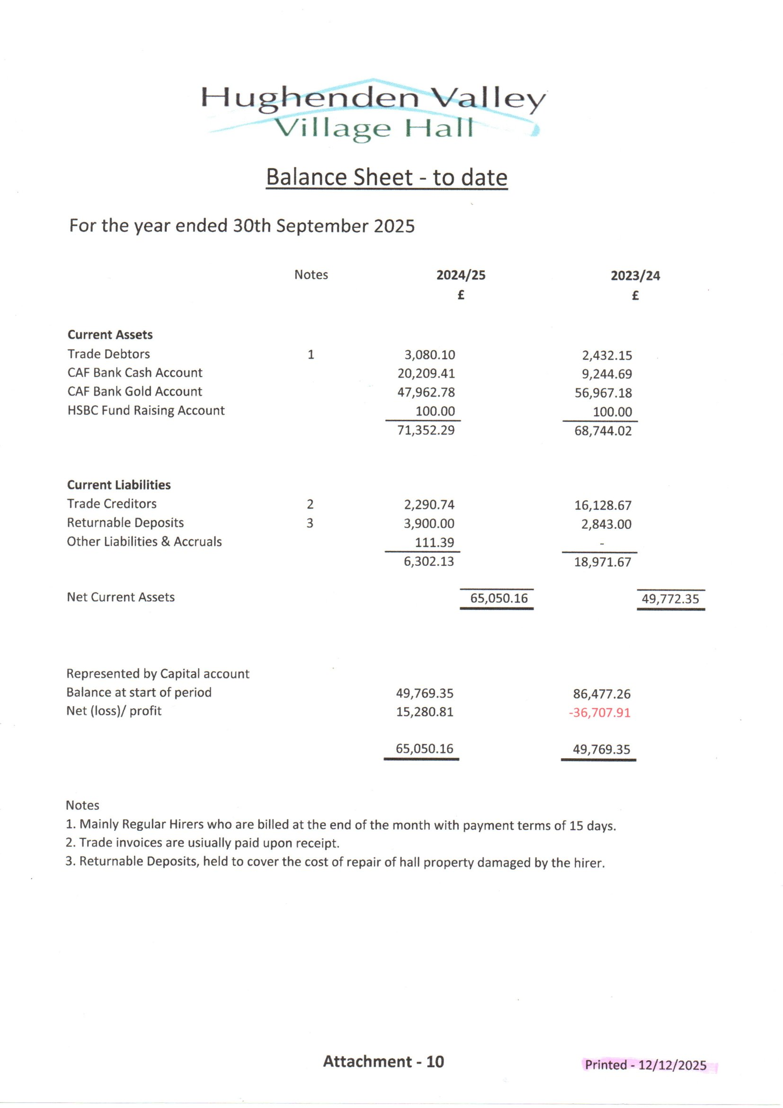

2024-2025 Profit & Loss
